Technical Note – Differing plasma conditions affect the calibration lines in Hg lamps.
April 2023

As part of our process for calibrating spectrometers, LightMachinery has purchased a variety of Mercury (Hg) calibration lamps from several different manufacturers. These calibration lamps generally contain a mixture of mercury and argon. An electric current generates a discharge in the lamp, and the excited gas plasma emits narrowband emission lines at known wavelengths [1]. Mercury ions emit a very strong line at 546.073 nm that is regularly used to calibrate spectrometers operating in the visible.

We recently noticed an interesting difference in the plasma emission from Hg/Ar lamps supplied by three different manufacturers. Figure 1 shows the three calibration lamps.

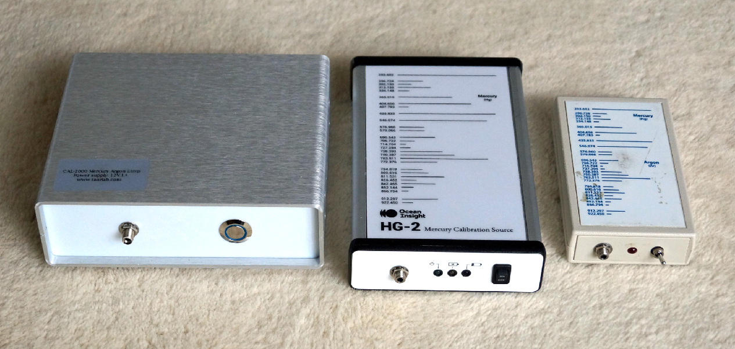

Figure 1 – Three calibration lamps from (left to right) Taorlab, Ocean Insight, and Ocean Optics. The Hg emission from each lamp is coupled out via a SMA fiber connector. A 105-um diameter fiber was used to couple the light from the lamp to the spectrometer.

The spectra of the lamps were taken with an HF-8989-2 spectrometer. This VIPA-based cross-dispersion spectrometer has a resolution of 1 pm in the 546 nm wavelength range, and it is this high resolution that allows us to see the differences in the plasma emission from the lamps [2].

In Figure 2 below, we show spectra taken of the hyperfine structure of the 546.1 nm line of mercury using two of the lamps.

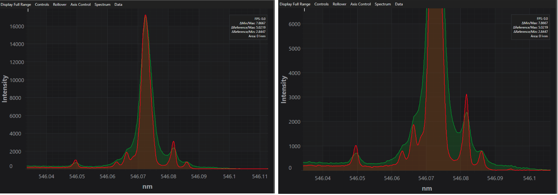

Figure 2 – Hyperfine structure of the Hg emission line at 546.1 nm as measured for the Taorlab lamp (red) and Ocean Optics lamp (green). An expanded view is shown on the right-hand side. The measured FWHM of the central peaks are 3.3 and 4.3 pm respectively, hence the fine structure of the Hg line is significantly better resolved with the Taorlab lamp.

The high resolution of the HF-8989-2 spectrometer ensures that there is minimal instrumental broadening of the spectral features – any differences in linewidths are caused by the differences in plasma conditions within the lamps. In a previous White Paper, we have discussed the magnetic hyperfine structure of Hg [3]. Figure 2 from that paper is reproduced below.

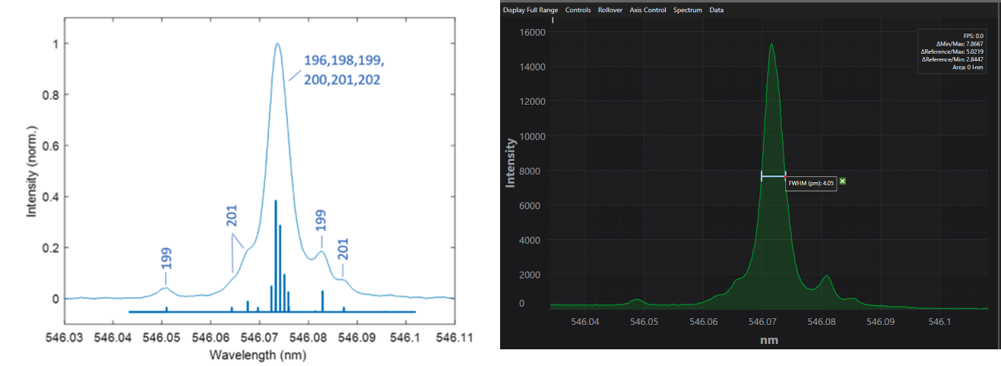

Figure 3 – The left-hand side shows the hyperfine structure of the 546.1 nm line of mercury. The spectral width of the observed features is limited by the plasma conditions in the Ocean Optics lamp. The dark blue lines underneath the spectrum display the known hyperfine magnetic structure of mercury [3]. On the right-hand side is a spectrum taken with an Ocean Insights lamp. The slightly narrower FWHM (4 pm) results in slightly more distinct hyperfine features.
As an additional experiment, we carried out a test using a compact fluorescent lamp, CFL. These light bulbs can be purchased for a few dollars and are known to emit many of the standard Hg calibration lines. As shown in Figure 4, the light from the CFL was coupled into the spectrometer by simply holding the 105-micron fiber against the surface of the light bulb.
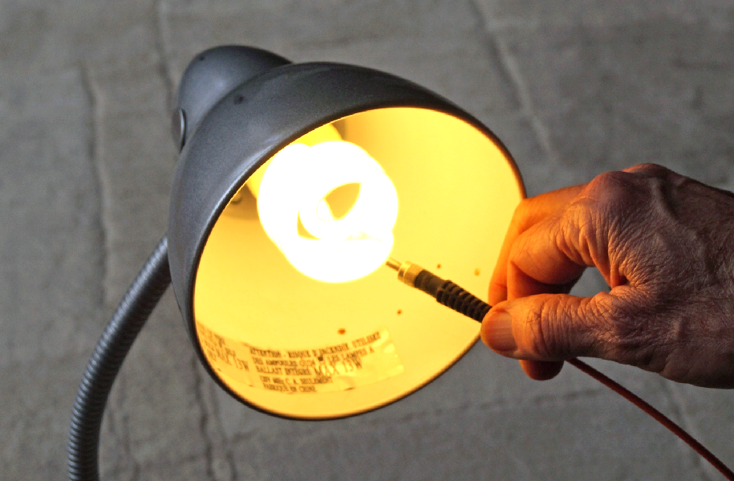
Figure 4 – Simple coupling scheme using an inexpensive CFL and a 105-micron fiber.

Figure 5 compares the spectra of the Taorlab lamp with that of the CFL.

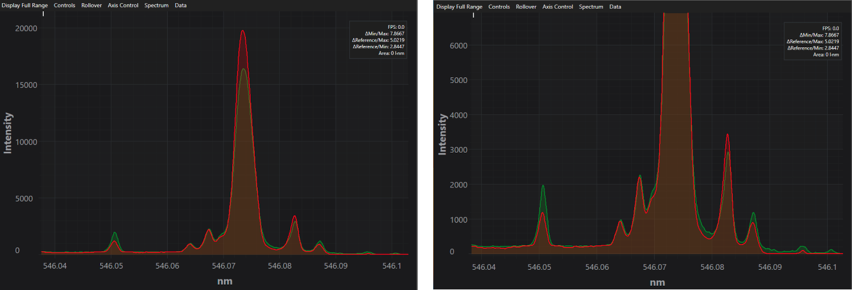

Figure 5 - Repeat of Figure 2, but this time comparing the Taorlab spectrum (red) with the spectrum of an inexpensive CFL. Note that the fine structure is resolved equally well for the two lamps and is significantly better resolved than for either the Ocean Optics or Ocean Insight lamps.

One a final note, it is worth mentioning that the intensity of the light emitted by the four lamps also differs significantly. By comparing the spectra of the four lamps for a variety of exposure times on the spectrometer sensor we estimate the relative intensities of the 546.1 nm Hg line to be 8:4:1 for the Taorlab, Ocean Insight and Ocean Optics lamps, respectively. The CFL has the same intensity as the Ocean Insight lamp.

Conclusions

By using a spectrometer with a resolving power of ~100,000 [4], we can measure significant differences in the observed hyperfine structure of the 546.1 nm reference line of Hg in four different lamps. Three of these lamps are calibration lamps that are sold for the express purpose of calibrating spectrometers. The fourth lamp, an inexpensive compact fluorescence lamp, demonstrates a well-resolved hyperfine structure that is very similar to the best of the three calibration lamps. We attribute the differences in the observed spectra to differences in the plasma conditions in the various lamps.

Footnotes

[1] – NIST provide very useful tables of the line positions of all the strong emission lines at https://physics.nist.gov/PhysRefData/Handbook/element_name.htm

[2] – More details of the operating principles of these spectrometers can be found at https://lightmachinery.com/media/1857/hyperfine-principles-of-operation.pdf

[3] - https://lightmachinery.com/media/1856/resolving-mercury-isotopes-with-the-hyperfine-spectrometer.pdf

[4] – Equivalent to ~1 pm resolution at 546 nm.

